**Experiment 3**

**Student Name:**Rajiv Paul **UID:**20BCS1812

**Branch:** CSE **Section/Group:** 702 A

**Semester:** 5th **Date of Performance:** 25/8/2022

**Subject Name:** DAA Lab **Subject Code:** 20-CSP-312

**1. Aim/Overview of the practical:**

Code to find frequency of elements in a given array in O(n) time complexity.

**2. Task to be done/ Which logistics used:**

To find the frequency of element in an array.

**3. Algorithm/Flowchart (For programming based labs):**

**4. Steps for experiment/practical/Code:**

*package com.DAA*;

*import java.util.*\*;

*public class DAA_exp1_3* {

*public static void* main(*String*[] *args*) {

*int* []arr = {1,7,7,9,9,8,3,2,5,10};

*Count*(arr, arr.length);

}

*static void* Count(*int* []*arr*,*int n*){

*int*[] hash = *new int*[*n*];

*Arrays*.*fill*(hash, 0);

*int* i = 0;

*while* (i < *n*)

{

hash[*arr*[i] - 1]++;

i++;

}

*for*( int j = 0; j < *n*; j++)

{

*System*.out.println((j + 1) + " --> " + hash[j]);

}

}

}

**5. Observations/Discussions/ Complexity Analysis:**

Time complexity of calculating frequencies of the elements in an array is O(n).

**6. Result/Output/Writing Summary:**

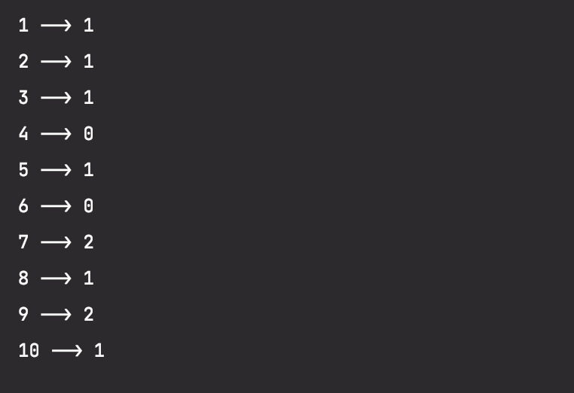

**Learning outcomes (What I have learnt):**

**1. Learnt how to calculate frequencies of the elements in an array.**

**2. Learnt about the hash map.**

**3. Learnt how to use hash.**

**4.**

**5.**

**Evaluation Grid (To be created as per the SOP and Assessment guidelines by the faculty):**

|  |  |  |  |
| --- | --- | --- | --- |
| Sr. No. | Parameters | Marks Obtained | Maximum Marks |
| 1. |  |  |  |
| 2. |  |  |  |
| 3. |  |  |  |
|  |  |  |  |